MJPTBCWRDC
STATION GHANPUR
LOCATED AT PEMBERTHI
(AFFILIATED TO KAKATIYA UNIVERSITY)
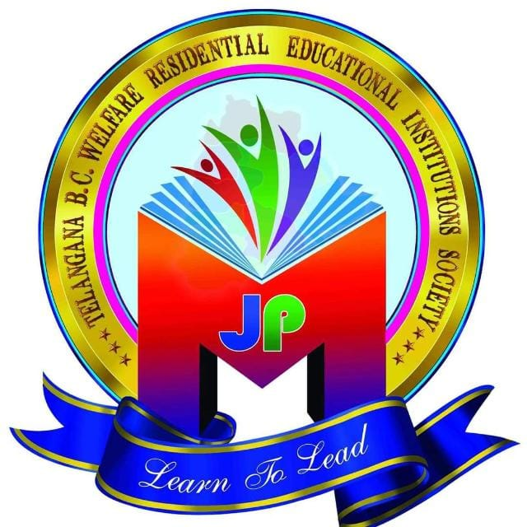

DEPARTMENT OF
COMPUTER SCIENCE

Department Profile—Computer Science
Vision
To produce the competent and ethically strong professionals with a bent towards research and innovation and thus the societal development.
Mission
To educate the students to create and apply knowledge in the Computer Science related domains, to be successful for the economic well-being of dynamically evolving society.
The students are trained in the following
1. Programming Languages
2. Databases
3. Data Warehousing and Mining
4. Cloud Computing
5. Mobile Computing
6. Software Engineering
7. Computer Networks
8. Information Security
9. Mobile Applications
10. Open Source Operating Systems

Infrastructural facilities
SYSTEMS CONFIGURATION
CLIENT SYSTEMS
ACER - 21 systems
FEATURE | DESCRIPTION
Processor | Intel(R) Core (TM)2 Quad CPU Q8300 @ 2.50GHz 2.50 GHz
RAM | 2.00 GB
Hard Disk | 300 GB
System Type | 32-bit Operating System

ABOUT THE DEPARTMENT
The MJPTBCWRDC(W) St. Ghanpur has started in the academic year 2022. The College has its inception in 2021 but functioning from the year 2022-2023 with Three basic courses i.e., B.Sc. (BZC), B.Sc. (MPCS) & B. Com (C.A) in English Medium and affiliated to the Kakatiya University @ Warangal.
The Degree College offered Science, Arts& Commerce Courses. Since the establishment of the college, the Computer Science Department has been extending remarkable service to the rural people by upgrading values and culture of learning.
Most of the students are BCs with rural background and are economically poor. They are given good education to increase the standards of the students.
The department strictly adhered to the academic schedule of the Kakatiya University a part from the syllabus.
The department maintains all academic records. The department also prepares an annual plan with different programs to have a more systematic approach while imparting the subject to the students.
The departmental meeting is arranged at the beginning of the academic year and whenever necessary.
Department cooperates in college administration by participating in admission work, clean and green, examination work and conducting literary, cultural activities.
EVALUATION
Apart from internal assessments continuous evaluation is done through Internal Assessments/Assignments/Class room seminars and Question and answer sessions.

CURRICULUM

Initially the syllabus for Computer Science was adopted from the syllabus of Kakatiya University, Warangal.
Staff members maintain regularly teaching diaries, synopsis and prepare annual academic planning at the beginning, scrutinized by the Principal.
The staff has been constantly attending Refresher and Orientation courses for updating their knowledge in view of changes that have been taking place in the syllabus. Besides, the members of the staff enthusiastically attend Seminars, Conferences regularly.
Department meetings are arranged regularly to discuss various issues pertaining to academic as well as administrative matters. The minutes are recorded in the Minutes book of the department. Time -Table is framed and workload distributed among the staff as per the Time-Table.

FACULTY PROFILE:
Personal Profile

Name : RAJANI DUDIPALA
Fathers Name : NARENDER REDDY
Date of Birth : 13-02-1987
Languages Known : English and Telugu
Mobile:+918555022163.
Email:reddydudipala.rajani@gmail.com
Technical Skills:
- Good knowledge of computers and ability to use it to maintain the academic records of the students
- Web development
- Databases such as Oracle
- Operating systems
- Computer Languages such as C++ and Java
Education:
- Master’s degree in Computer Science from Osmania University, in the year 2011
- Bachelor’s degree in Physical Science from Kakathiya University, in the year 200.
Experience:
- Worked as a Computer Science & Applications Lecturer in Saghamithra Degree & P.G. College for 3 years from 2014-17
- Worked as a Computer Science & Applications Lecturer in Sri Sri Gayatri Degree College for 2 years from 2017-19.
- Worked as a Computer Science & Applications Lecturer in Ekashila Degree College for 1 years from 2021-22
- Worked as a Computer Science & Applications Lecturer in MJPTBCWRDC at pembarthy for 2 years from 2022-24

Personal Details
Name | Dr Lavanya Neerati
Date of Birth | 03 February 1989
Father name | N. Balaraju
Languages Known | English, Telugu, Hindi
Sex | Female
Marital Status | Married
Nationality | Indian
Hobbies | Playing caroms and watching TV
Current Address | H.No-398/1, RR Colony , Opp Railnilayam, Secunderabad-500071.
Contact details:
E-Mail:nlavanya12@gmail.com
Mobile: +91 9704996583

Working experience
- Worked as an Assistant Professor of Computer Science & Engineering in CMR College of Engineering & Technology(Autonomous) from June 2013 to April 2018.
- Worked as an Teaching Assistant for UG under the guide Prof P.Preamchand of Computer Science & Engineering in OUCEfrom August 2018 to April 2020.
- Worked as a part-time trainer in Talentio institute from July 2018 to Jan 2020.

Achievements
- Have qualified National Eligibility Test (NET) for Assistant Professor in Dec – 2018.
- Have qualified State Eligibility Test (SET) – 2017 for Telangana states
- Have qualified Faculty Eligibility Test (FET) - 2013.
- Outstanding performance certificate in one week FDP on “Teaching Methodologies”.
- Academic excellence award in the year 2010-2011.
- Academic excellence award in the year 2009-2010.
- Academic excellence award in the year 2008-2009.

Notable Contributions
- Guided Two M.Tech., and Eight B.tech. (Degrees awarded) Students for Project work in the faculty of Computer Science and Engineering
- Did many observer duties for recruitment and CMRCET exams
- Organizing team member of Two day National Conference ‘INFOSEC-2013 & 2014’,

Workshops and Conferences
- Participated International Conference (ICCCSAI 2017) at Sree vidyanikethan college of engineering and technology , Tirupati.
- Attended Faculty Development Programs (FDP) conducted by NITW in association with ICT on “software testing methodologies and Algorithms”.
- Participated in one day preconference work shop on “Computational Intellgence: Recent Trends” conducted by School of IT, JNTUH, Hyderabad.
- Participated in one week FDP on “Teaching Methodologies” conducted by CMRCET at Hyderabad.
- Participated in FDP on “Research Issues and Methodologies in Computer Science & Engineering” conducted by CMRCET at Hyderabad.
- Participated in one week FDP on “Research Proposals, Funding Agencies, Opportunities and Methodologies” conducted by CMRCET at Hyderabad.

Publications
- "Neuronal instability as a biomarker of e-SoZ for the electroencephalograph", volume 26 issue:3 Suplement,S42, INS-IM2022 ,April2023.
- “ Effect of Microelectrode Recording in Exact Targeting STN with High Frequency DBS in Parkinson Disease Using Unsupervised Machine Learning Techniques " has been allocated for publishing in IETE Journal of Research in Jan-Feb 2022; Volume 68, Issue 1.
- “Machine learning supervised classification study for Parkinson`s disease progression through graph-based feature selection method”, International Congress of Parkinson`s Disease and Movement Disorders on September15,2022.
- “Execution of scientific tractography for presurgical preparation of area seizing abrasions: A study through the acquisition plus post-processing techniques contrasted to investigational revisions” , International Congress of Parkinson`s Disease and Movement Disorders on September15,2022.
- “Advanced Computing in Human Movement and Control: A study with Nano Sensors Deep Brain Stimulation Pulse Generators and Machine Learning” publication in CCIS Series of Springer.
- “A Smart microelectroneuro—Sensor multichannel emg for effective medical diagnosis”, Lavanya N published in International conference --World Congress Biosensors.
- “Protecting Patient Health Documents by Enhancing Security on Cloud” N.Lavanya ,published in Journal of advanced Research in Dynamic & Control System, during Jan 2018.
- “Latent variate factorial principal component Analysis of microelectrode recording of subthalamic-nuclei neural signals with deep brain stimulator in Parkinson disease” N.Lavanya, Published in International Journal of Bio Informatics, during jan 2018.
- “Robust And Secure Data Hiding In Image Using Biometric Technique”, N.Lavanya, Published in the Journal IJCSIT , during September 2012.

Subjects Handled
- Design & Analysis of Algorithms
- C Programming
- C++
- Data structures.
- Advanced Data Structures.

Technical Skills
Operating System | Windows XP/7/8, MS-DOS and Unix.
Languages | C, c++.
Database & Application Tools | SQL, UML, HTML, XML and Web services.

Academic Back-Ground
Course | From | Duration & percentage of Score achieved
PhD (Pursuing ) (Computer Science & Engineering) | OSMANIA UNIVERSITY | 2018---
M. Tech. (Computer Science & Engineering) | Institute of Areonautical Engineering And Technology, JNTUH, Hyderabad | 2010-2012 with Distinction
B. Tech. (Computer Science & Engineering) | Institute of Areonautical Engineering And Technology, JNTUH, Hyderabad | 2006-2010 with  Distinction
Intermediate | MVVM College, Begumpet. | 2004 -2006 with 70.1%
SSC | Tagore’s High School, Gandhinagar | 2003 - 2004 with 79.1%

Personal Skills
- Comprehensive problem solving abilities.
- Ability to deal with people diplomatically.
- Willingness to learn new technologies.
- Flexible and can work in a team.

Extra Curricular Activities
- Event organizer and other technical events in CMRCET.
- Class Representative in B.Tech.
- Actively involved in the accreditation process of AICTE ,NAAC and UGC
- Organized several workshops and seminars in CMRCET

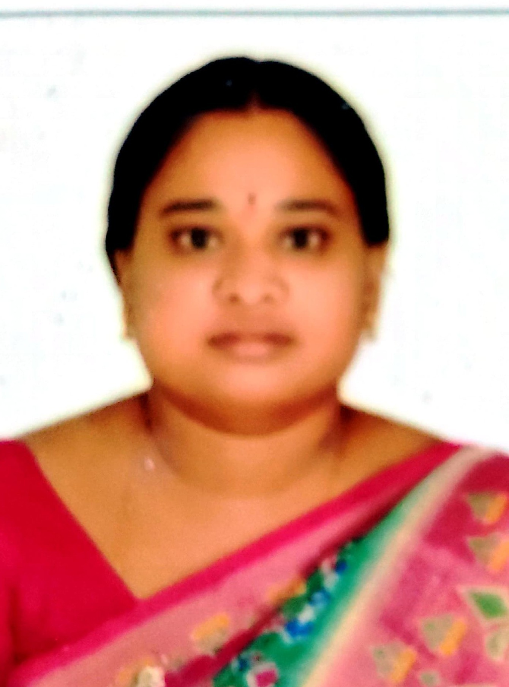
Nalinakshi M
nalinakshi9@gmail.com Plot no 907,
SKD Nagar, Vanasthalipuram, R R Dist 500070
Telangana.
Mobile : +919573774897
CAREER OBJECTIVE
To obtain a challenging position in a high quality engineering environment where my resourceful experience and academic skills will add value to organizational operations.
ACADEMIC DETAILS
- M. Tech(Computer Science and Engineering [2010] with aggregate of 71% from JNTU Hyderabad
- B.Tech(Computer Science and Engineering) [2005] with aggregate of 60% from JNTU Hyderabad
- Diploma(Polytechnic in Computer Engineering) [2002] with aggregate of 63% from SBTET, HYDERABAD
- Ssc [1999] with aggregate of 60% from BSE HYDERABAD
WORK EXPERIENCE
- Working as Degree Lecturer in MJPTBCWRDC (WOMEN), GOVT. TELANGANA from Jul 2024 to till date Role :Degree lecturer
- Worked as Assistant professor in Holy Mary Institute of Science and Technology from Feb 2015 to Jun 2024 Role :Assistant professor
- Worked as Assistant professor in JB Institute of Engineering and Technology from Feb 2010 to Feb 2015 Role :Assistant professor
PROJECT DETAILS
  - B. Tech final year projects
Description : On Web technologies, Java,
Duration : 1 year
Role : Guide
Team Size : 5
  - B. Tech III Year mini projects
Description : On HTML, CSS, JAVA C#
Duration : 6 Months
Role : Guide
Team Size : 3
FIELD OF INTEREST
- Education
SKILLS
- C. C++, Java, SQL, HTML, JAVA SCRIPT, ASP,.
INDUSTRIAL EXPOSURE
Implant Training at:
- MHRD 3 Day Traing program , Fdp at HCU, Dy. Warden one day training program.
ACHIEVEMENTS
- Gate 2007 Qualified, UGC- NET 2012, APSET -2012
CURRICULAR ACTIVITIES
- TASK Placement officer,
- Dy. Warden at MJPTBCWRDC (WOMEN)
STRENGTH & HOBBIES
- Good Communicational skills, observation on content, Analytical
- To play chess, corroms, Outdoor Games, Cooking, and Reading .

- Academic Programs:
B.Sc. MPCs
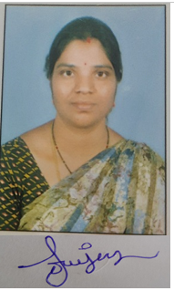
B Com (CA)
- Faculty
Sowjanya Thuppathurthi MCA, B Ed.
- Educational Qualifications:
Completed MCA in 2010, SR Engineering College Affiliated to JNTU
Completed B Ed in 2015, Sravanthi College of Education Affiliated to KU at
Dharmaram, Warangal.
- Teaching Experience:

- I have total 5 Years of Teaching Experience.

- Worked as Degree Lecturer Computer Science & Application at New Science Degree & PG College, Hanamkonda, Warangal from 2012 to 2015.

- Worked as Degree Lecturer Computer Science & Application at Kakathiya Govt College (KDC), Hanamkonda, Warangal from 2023 to 2024.

- Worked as Degree Lecturer Computer Science & Application at Pingle Degree College for Women, Hanamkonda, Warangal from 2024 to 2025.

- Currently working as a Degree Lecturer in Computer Science & Application at MJPTBCWRDC, Station Ghanpur located at Pembarti, Jangaon.

- Contact Details:
E Mail:-soujbadri@gmail.com
Mobile: +91 9000940930

